|  |
| --- |
| Formative Assessment Instrument |
| ***Module 1*** |

**NATIONAL Certificate:**

**GENERIC MANAGEMENT**

**59201**

**GENERIC MANAGEMENT**

**(LP60269)**

**Skills Program 1-**

**People Management**

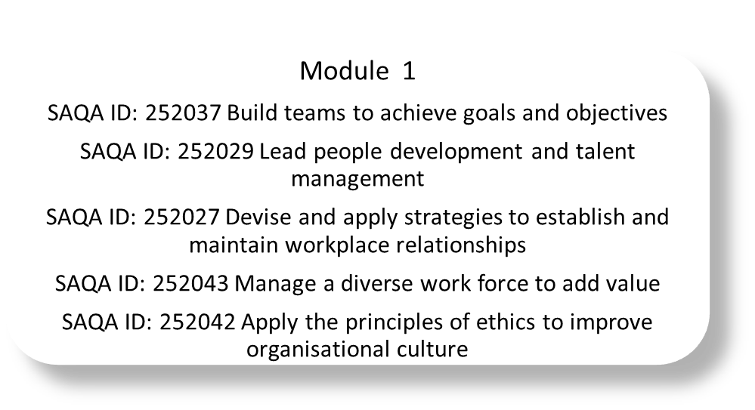

Non-Accredited Programme

SECTION 1: FORMATIVE ASSESSMENT INSTRUMENT

Learner Name & Surname:

_____________________________

Company Name:

______________________________________

**Welcome to your Formative Assessment!**

This document deals with the formative assessment of your competence towards the outcomes which you need to achieve. “Formative Assessment refers to assessment that takes place during the process of learning and teaching”

The formative assessment activities and questions in this section count towards your overall competence for this skills programme.

Ensure that all the questions are answered in full giving examples where asked.

**FORMATIVE ASSESSMENT**

* 1. **knowledge questionaire**

**Instructions to the Learner:** The following questions must be answered in full giving examples where asked. Please read all the questions carefully and take time to consider your answer before recording it.

|  |
| --- |
| UNIT STANDARD: 252037 Build teams to achieve goals and objectives |

**Important Note**: Should any additional information / documents be required or attached, kindly ensure that you have referenced them accurately as identified in each section.

|  |
| --- |
| **Essential Embedded Knowledge** |

1. Explain the importance of keeping a team of staff well motivated.

|  |
| --- |
|  |
|  |
|  |
|  |
|  |

|  |
| --- |
| **Essential Embedded Knowledge** |

1. Explain the impact of group dynamics on the performance of the group.

|  |
| --- |
|  |
|  |
|  |
|  |
|  |
|  |

|  |
| --- |
| **US REFERENCE: SO 2 AC 1** |

1. List your own strengths and areas for development, based on self-reflection and feedback that you have received from others in your workplace.

|  |  |
| --- | --- |
| **Strengths** | **Weaknesses** |
|  |  |
|  |  |
|  |  |
|  |  |
|  |  |
|  |  |

**Section B: Multiple Choice Questionnaire**

**Instructions:** Complete the following multiple choice questions by selecting the correct answer from the options provided. Mark your selection with an “X” below to indicate the correct choice/s.

|  |
| --- |
| **Essential Embedded Knowledge** |

1. Identify two (2) of the following methods which are widely used to motivate the performance of a team.

|  |  |  |  |
| --- | --- | --- | --- |
| Choice A | Choice B | Choice C | Choice D |
| Threaten with retrenchment | Performance incentives | Become friends with team members on a personal basis | Opportunities for growth / promotion |
|  |  |  |  |

|  |
| --- |
| **Essential Embedded Knowledge** |

1. Identify the possible impact on the team’s performance should there not be a clear line of communication within the department and amongst team members.

|  |  |  |  |
| --- | --- | --- | --- |
| Choice A | Choice B | Choice C | Choice D |
| Promotion for team members | Decrease in overall performance of team | Improved customer service | Increase in mistakes and errors made |
|  |  |  |  |

|  |
| --- |
| **US REFERENCE: SO 1 AC 1** |

1. Describe the characteristics of a team and team interaction when compared to that of a group. Make use of an example to explain your answer.

|  |
| --- |
|  |
|  |
|  |
|  |
|  |
|  |
|  |

|  |
| --- |
| **US REFERENCE: SO 1 AC 2** |

1. Describe different teams of staff within your workplace and explain the role of each.

|  |  |
| --- | --- |
| Team | Role and characteristics |
| i) |  |
| ii) |  |
| iii) |  |

|  |
| --- |
| **US REFERENCE: SO 1 AC 3** |

1. Explain the importance of teams achieving workplace goals and objectives.

|  |
| --- |
|  |
|  |
|  |
|  |
|  |
|  |

|  |
| --- |
| **US REFERENCE: SO 2 AC 1** |

1. Make use of practical examples to explain the dynamics of a team.

|  |
| --- |
|  |
|  |
|  |
|  |
|  |
|  |

|  |
| --- |
| **US REFERENCE: SO 2 AC 2** |

1. Explain the reasons for disagreements and conflict which occur that could disrupt the functioning of the team.

|  |
| --- |
|  |
|  |
|  |
|  |
|  |
|  |

|  |
| --- |
| **US REFERENCE: SO 2 AC 3** |

1. Give examples of cross-functional and virtual teams. Make use of examples to explain your answer.

|  |
| --- |
|  |
|  |
|  |
|  |
|  |
|  |
|  |

|  |
| --- |
| **US REFERENCE: SO 2 AC 3** |

1. Identify unique challenges that could be faced by cross-functional and virtual teams. Make use of examples to explain your answer.

|  |  |
| --- | --- |
| Cross-functional teams | Virtual teams |
|  |  |
|  |  |
|  |  |

|  |
| --- |
| **US REFERENCE: SO 3 AC 1** |

1. Explain the steps of the process in building a team.

|  |
| --- |
|  |
|  |
|  |
|  |
|  |
|  |
|  |
|  |
|  |
|  |
|  |
|  |

|  |
| --- |
| **US REFERENCE: SO 3 AC 2** |

|  |
| --- |
| **US REFERENCE: SO 4 AC 1** |

1. Explain the role of the team leader in terms of improving the team’s effectiveness.

|  |
| --- |
|  |
|  |
|  |
|  |
|  |
|  |
|  |
|  |

|  |
| --- |
| **US REFERENCE: SO 4 AC 2** |

1. Describe the impact of different leadership styles in relation to the leader's role in promoting team effectiveness.

|  |  |
| --- | --- |
| Leadership style | Impact on the leader’s role to promote effectiveness |
|  |  |
|  |  |
|  |  |
|  |  |
|  |  |

|  |
| --- |
| **US REFERENCE: SO 4 AC 3** |

1. Identify the techniques which could be used to constructively manage team dynamics and conflict in terms of the following factors: promoting trust, cohesion, creativity and productivity.

|  |
| --- |
| Technique used to promote trust: |
| Technique used to promote cohesion |
| Technique used to promote creativity: |
| Technique used to promote productivity: |

|  |
| --- |
| UNIT STANDARD: 252029 Lead people development and talent management |

**Important Note**: Should any additional information / documents be required or attached, kindly ensure that you have referenced them accurately as identified in each section.

|  |
| --- |
| **Essential Embedded Knowledge** |

1. Explain the impact of demonstrating effective leadership skills in the workplace.

|  |
| --- |
|  |

|  |
| --- |
| **Essential Embedded Knowledge** |

1. List the characteristics of an effective leader.

|  |
| --- |
|  |

|  |
| --- |
| **Essential Embedded Knowledge** |

1. Explain the importance for a leader to adhere to the organisational policies and procedures at all times.

|  |
| --- |
|  |

**Section B: Multiple Choice Questionnaire**

**Instructions:** Complete the following multiple-choice questions by selecting the correct answer from the options provided. Mark your selection with an “X” below to indicate the correct choice/s.

|  |
| --- |
| **Essential Embedded Knowledge** |

1. Identify the impact of identifying problems quickly and implementing corrective actions.

|  |  |  |  |
| --- | --- | --- | --- |
| Choice A | Choice B | Choice C | Choice D |
| To avoid the problems from becoming worse | To avoid staff from interacting with clients | To resolve the issues and resume workflow | To promote better community involvement |
|  |  |  |  |

|  |
| --- |
| UNIT STANDARD: 252027 Devise and apply strategies to establish and maintain workplace relationships |

**Important Note**: Should any additional information / documents be required or attached, kindly ensure that you have referenced them accurately as identified in each section.

|  |
| --- |
| **Essential Embedded Knowledge** |

1. Explain the importance of keeping a team of staff well motivated.

|  |
| --- |
|  |

|  |
| --- |
| **Essential Embedded Knowledge** |

1. Explain the impact of group dynamics on the performance of the group.

|  |
| --- |
|  |

|  |
| --- |
| **US REFERENCE: SO 2 AC 1** |

1. List your own strengths and areas for development, based on self-reflection and feedback that you have received from others in your workplace.

|  |  |
| --- | --- |
| **Strengths** | **Weaknesses** |
|  |  |

**Section B: Multiple Choice Questionnaire**

**Instructions:** Complete the following multiple-choice questions by selecting the correct answer from the options provided. Mark your selection with an “X” below to indicate the correct choice/s.

|  |
| --- |
| **Essential Embedded Knowledge** |

1. Identify two (2) of the following methods which are widely used to motivate the performance of a team.

|  |  |  |  |
| --- | --- | --- | --- |
| Choice A | Choice B | Choice C | Choice D |
| Threaten with retrenchment | Performance incentives | Become friends with team members on a personal basis | Opportunities for growth / promotion |
|  |  |  |  |

|  |
| --- |
| **Essential Embedded Knowledge** |

1. Identify the possible impact on the team’s performance should there not be a clear line of communication within the department and amongst team members.

|  |  |  |  |
| --- | --- | --- | --- |
| Choice A | Choice B | Choice C | Choice D |
| Promotion for team members | Decrease in overall performance of team | Improved customer service | Increase in mistakes and errors made |
|  |  |  |  |

|  |
| --- |
| UNIT STANDARD: 252043 Manage a diverse work force to add value |

**Important Note**: Should any additional information / documents be required or attached, kindly ensure that you have referenced them accurately as identified in each section.

|  |
| --- |
| **Essential Embedded Knowledge** |

1. Explain the importance of having clear and manageable performance goals.

|  |
| --- |
|  |

|  |
| --- |
| **Essential Embedded Knowledge** |

1. Explain the importance of monitoring performance of staff on a regular and on-going basis.

|  |
| --- |
|  |

|  |
| --- |
| **Essential Embedded Knowledge** |

1. Explain the benefits of measuring the performance of both the staff individually and the department as a whole.

|  |
| --- |
|  |

**Section B: Multiple Choice Questionnaire**

**Instructions:** Complete the following multiple-choice questions by selecting the correct answer from the options provided. Mark your selection with an “X” below to indicate the correct choice/s.

|  |
| --- |
| **Essential Embedded Knowledge** |

1. Identify the possible impact of not proving feedback to staff on their performance at work.

|  |  |  |  |
| --- | --- | --- | --- |
| Choice A | Choice B | Choice C | Choice D |
| Staff will be able to improve performance | Staff will work harder to reach objectives | Staff will not know how to improve performance | Staff will have enjoy improved working conditions |
|  |  |  |  |

|  |
| --- |
| **Essential Embedded Knowledge** |

1. Identify the direct impact of maintaining accurate records on past performance evaluations conducted with staff members.

|  |  |  |
| --- | --- | --- |
| Choice A | Choice B | Choice C |
| Will enable company and staff to review performance levels | Will improve the amount of company benefits to staff | Will cause unnecessary delays and increased workload |
|  |  |  |

|  |
| --- |
| UNIT STANDARD: 252042 Apply the principles of ethics to improve organizational culture |

**Important Note**: Should any additional information / documents be required or attached, kindly ensure that you have referenced them accurately as identified in each section.

|  |
| --- |
| **US REFERENCE: SO 1 AC 1** |

1. Explain the concepts of values, belief systems and ethics as they apply to your organisation.

|  |
| --- |
|  |

|  |
| --- |
| US REFERENCE: SO 1 AC 2 |

1. Identify the source(s) of values and belief systems and explain how your ethics and values can affect your behaviour. Make use of an example to explain your answer.

|  |
| --- |
|  |

|  |
| --- |
| US REFERENCE: SO 1 AC 3 |

1. Describe the ways in which an individual can change/adapt his/her belief or value system. Make use of an example to explain your answer.

|  |
| --- |
|  |

|  |
| --- |
| US REFERENCE: SO 2 AC 1 |

1. Describe how an individual’s ethics can impact on behaviour and interpersonal relationships.

|  |
| --- |
|  |

|  |
| --- |
| US REFERENCE: SO 2 AC 2 |

1. Explain the impact of personal ethics on the use of language.

|  |
| --- |
|  |

END OF ASSESSMENT